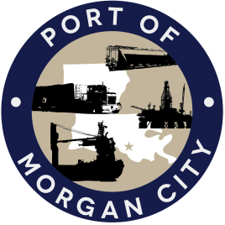

NOTICE OF PUBLIC MEETING

MORGAN CITY HARBOR AND TERMINAL DISTRICT COMMITTEE

Notice is given that a Meeting of the Committee (“Committee”) established by the Board of the Morgan City Harbor and Terminal District (“District”) at its June 12, 2017 meeting, has been called by the members of the Committee, namely, Ben Adams, Lee Dragna, Gary Duhon and Adam Mayon, for Friday, August 25, 2017 at 3:00 p.m. to be held at the District’s Offices at 7327 Highway 182, Morgan City, Louisiana. Said meeting has been called for the following purposes and to take appropriate action thereon, to wit:

AGENDA

- Call to Order

- Discussion and any action on Atchafalaya River Channel dredging and sediment management.

- Adjournment

In accordance with the Americans with Disabilities Act, if you need special assistance, please contact Tori Henry at 985-384-0850, describing the assistance that is necessary.

